AUTO TICKET CLASSIFICATION USING FLOW DESIGNER
PHASE 6 – PROJECT TESTING
Project Platform: ServiceNow Flow Designer
The objective of Phase 6 is to ensure that the developed solution works as expected, meets all functional requirements, validates the end-to-end automation, confirms data accuracy, and follows basic security and access control best practices.
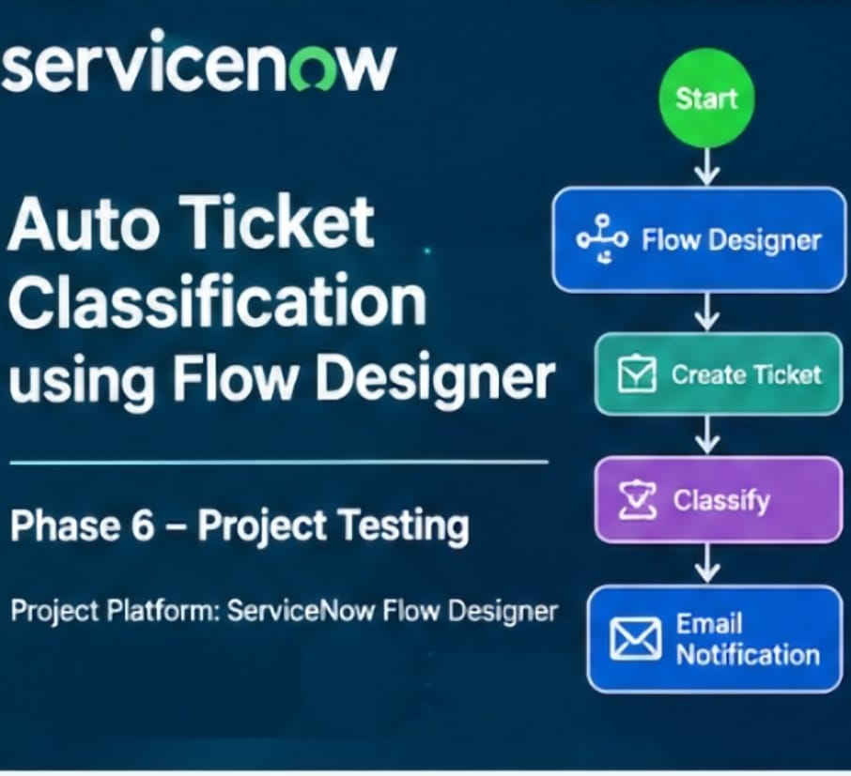

6.1 Testing Objectives
- Verify that mandatory fields are captured correctly.
- Verify that auto-number is generated without duplication.
- Verify that Category and Subcategory values are stored accurately.
- Verify that reference fields resolve correctly to user and group tables.
- Validate the end-to-end ticket classification automation.
- Verify that email notification is sent to the caller after ticket creation.
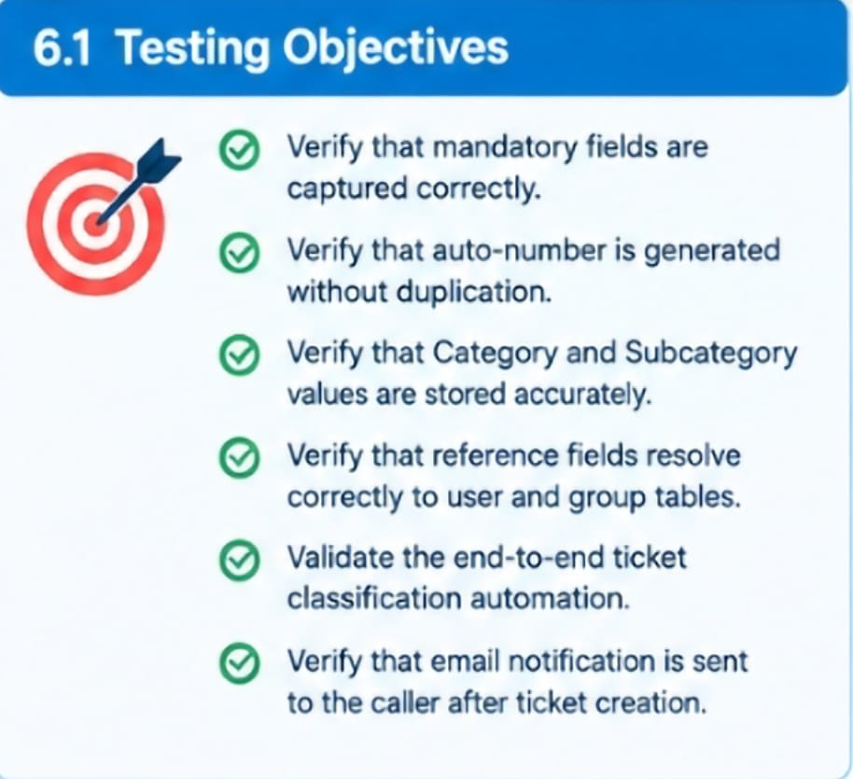

6.2 Data Validation Checks
- Mandatory fields captured correctly.
- Auto-number generated without duplication.
- Category and Subcategory values stored accurately.
- Reference fields resolve correctly to user and group tables.
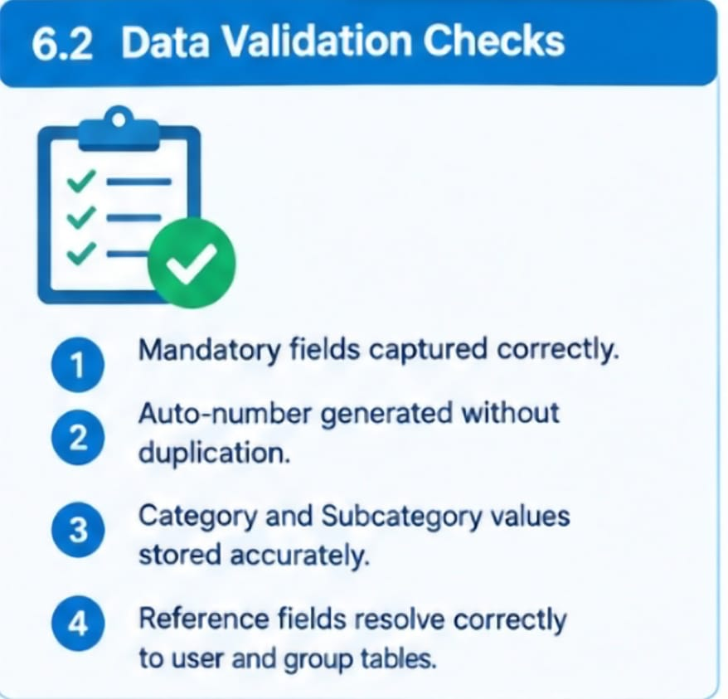

6.3 Test Scenario 1 – Wi-Fi Issue
- Enter one Caller Name.
- Short Description: WiFi not working in library.
- Save the form and reload the form.
- Expected Category: Network.
- Expected Subcategory: WiFi.
- Expected result: Email is sent to the caller's email ID.
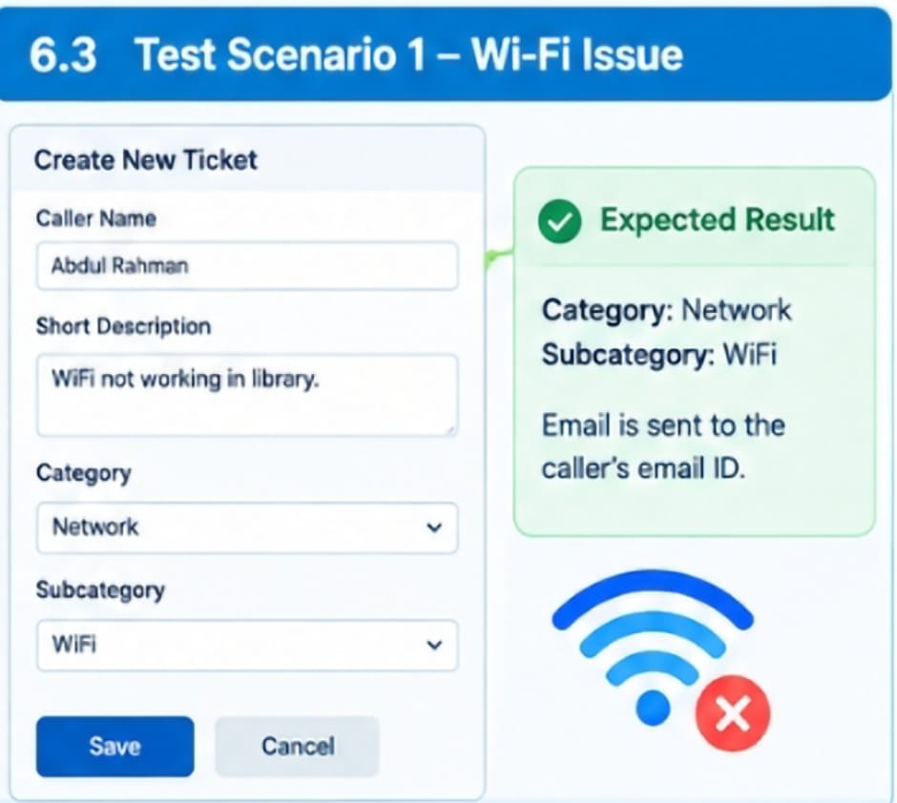

6.4 Email Notification Verification
- Open All menus and search Emails.
- Under System Logs, select Emails.
- Search using the given subject name.
- Open the email record and use Preview Mail to verify the notification.
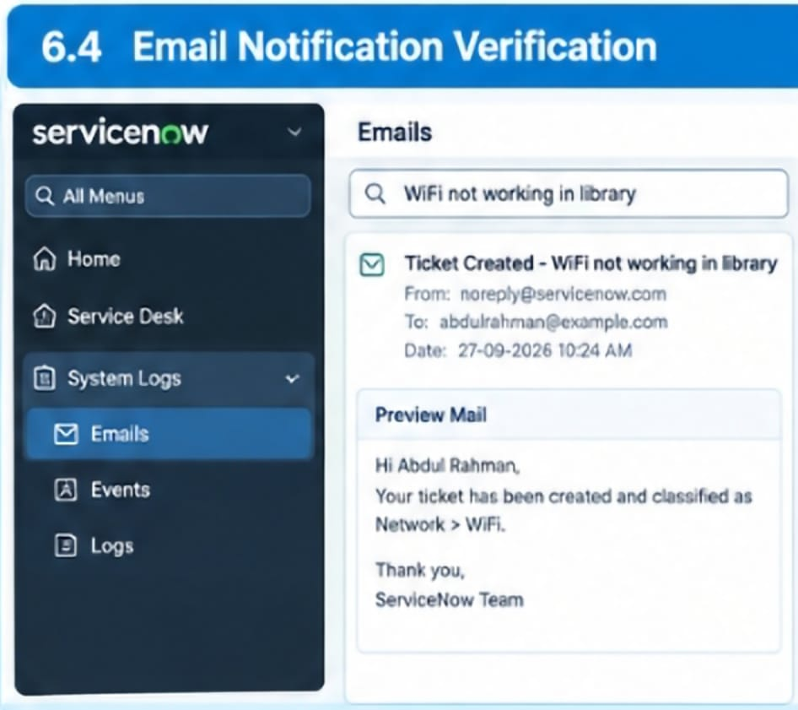

6.5 Test Scenario 2 – Projector Issue
- Enter one Caller Name.
- Short Description: Projector not turning on.
- Save the form and reload the form.
- Expected Category: Hardware.
- Expected Subcategory: Projector.
- Expected result: Email is sent to the caller's email ID.
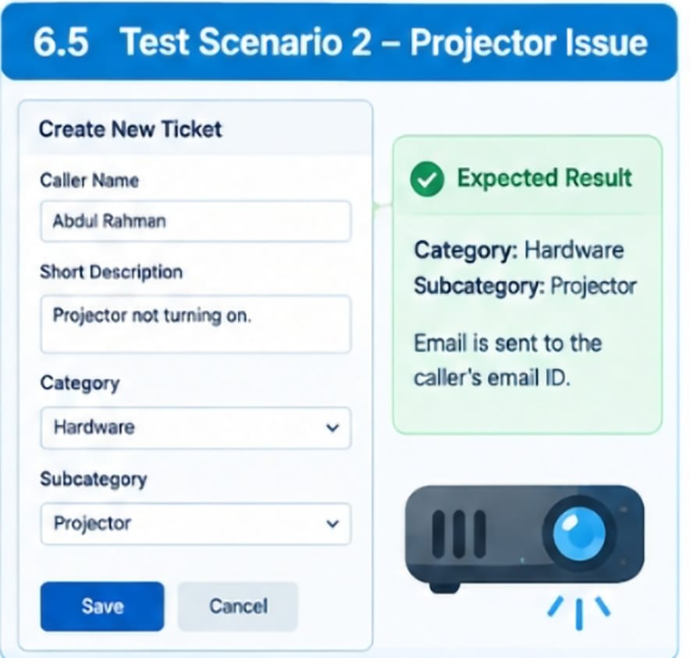

6.6 Security & Access Validation
- Ensure that only authorized users can access or modify ticket data.
- Validate that reference fields resolve correctly to user and group records.
- Maintain structured and standardized ticket information.
- Validate data integrity during ticket creation and automated updates.
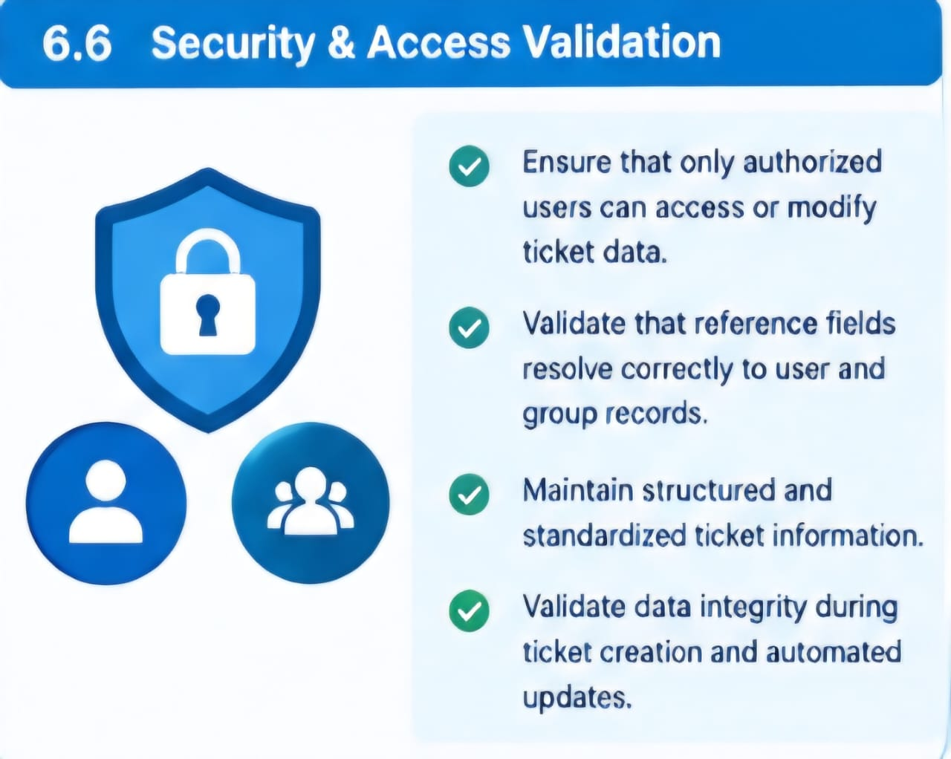

6.7 Testing Result
- The documented scenarios validate ticket creation, automatic classification, Category and Subcategory assignment, and email notification. These checks are used to confirm that the solution functions reliably and maintains accurate ticket data.



